

MECHATRONICS SYSTEM INTEGRATION (MCTA 3203)
SEMESTER 2 2025/2026

WEEK 2: DIGITAL LOGIC SYSTEM

SECTION 1
GROUP 7

INSTRUCTOR: DR WAHJU SEDIONO & ASSOC. PROF. EUR. ING. IR. TS. GS. INV.
DR ZULKIFLI BIN ZAINAL ABIDIN

NO | NAME | MATRIC NO
1 | MUHAMMAD FARISH BIN AB LATIF | 2329227
2 | MUHAMMAD DANISH BIN MOHD HANIFAH | 2311377
3 | MUHAMMAD FARQI SARHIDI BIN ABDUL HAFAZ | 2316461

DATE OF SUBMISSION: 18 MARCH 2026

TABLE OF CONTENTS
1.0 INTRODUCTION 3
2.0 MATERIALS AND EQUIPMENT 3
3.0 EXPERIMENTAL SETUP 4
4.0 METHODOLOGY 5
4.1 Circuit Setup 5
4.2 Program Development and Uploading 5
4.3 Program Operation 6
4.4 Coding 6

5.0 DATA COLLECTION..................................................................................................................... 11 6.0 DATA ANALYSIS...........................................................................................................................12 7.0 RESULTS.........................................................................................................................................13 8.0 DISCUSSION..................................................................................................................................18 9.0 CONCLUSION................................................................................................................................19 10.0 RECOMMENDATIONS............................................................................................................... 19 11.0 REFERENCES...............................................................................................................................21 ACKNOWLEDGEMENT..................................................................................................................... 22 STUDENTS’ DECLARATION.............................................................................................................22

1.0 INTRODUCTION
In this experiment, an Arduino Uno microcontroller was utilized to operate a common cathode 7-segment display. The display was managed using push buttons as input controls. One push button was assigned to increase the displayed number, while the other was used to reset the display back to 0. This setup illustrates how a microcontroller can send digital output signals to control external components, while simultaneously receiving input signals through push buttons.
The objective of this experiment is to demonstrate the interfacing of an Arduino microcontroller with a 7-segment display, as well as to observe how digital input and output processes can be applied to create a basic digital logic system

2.0 MATERIALS AND EQUIPMENT
- Arduino Uno board
- Common cathode 7-segment display
- 220-ohm resistors (7 of them)
- Pushbuttons (2 or more)
- Jumper wires
- Breadboard

3.0 EXPERIMENTAL SETUP
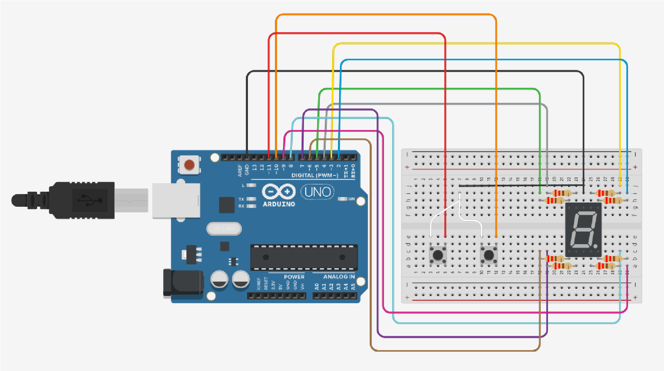
1.Connect the common cathode 7-segment display to the Arduino Uno as described below:
- Attach each of the seven segments (a, b, c, d, e, f, g) to individual digital pins on the Arduino (for example, pins D0 to D6).
Link the common cathode terminal of the display to one of the Arduino’s GND (ground) pins.

- Place 220-ohm resistors between each segment pin and the corresponding Arduino pin to regulate and limit the current flow
2.Connect the pushbuttons to the Arduino:
● Connect one terminal of each push button to different digital pins (for example, D9 and D10), while the other terminal of each push button is connected to GND.

● Implement 10 kΩ pull-up resistors for each push button by linking one end of the resistor to the corresponding digital pin and the other end to the Arduino’s 5V supply.

4.0 METHODOLOGY

4.1 Circuit Setup
- All required components including the Arduino Uno, 7-segment display, resistors, push buttons, breadboard, and jumper wires were prepared before assembling the
circuit.
- The 7-segment display segments (a–g) were connected to the digital pins of the
Arduino through 220 Ω resistors to limit the current and protect the LED segments.
- The common cathode pin of the display was connected to the ground (GND) terminal of the Arduino board.
- Push buttons were connected to designated Arduino digital pins to serve as increment and reset inputs.
- 10 kΩ pull-up resistors were used to stabilize the input signals and prevent floating input states.
- After completing the connections, the wiring was checked carefully to ensure correct connectivity and to avoid short circuits.

4.2 Program Development and Uploading
- The Arduino Integrated Development Environment (IDE) was launched on the computer.
- A new program was written to control the 7-segment display and read the push button inputs.
- The correct board type (Arduino Uno) and the appropriate COM port were selected from the Tools menu.
- The program was verified to check for compilation errors before uploading it to the
Arduino board.
- After successful compilation, the code was uploaded to the Arduino Uno through the
USB connection.

4.3 Program Operation
- The pins connected to the segments of the 7-segment display were configured as output pins, while the push button pins were configured as input pins.
- A variable was initialized to store the current count value.
- The Arduino continuously monitored the state of the push buttons inside the main program loop.
- When the increment button was pressed, the count value increased and the displayed number was updated accordingly.
- When the reset button was pressed, the count returned to zero, and the display showed the number “0”.
- A display control routine was used to activate the correct combination of segments to represent each number on the 7-segment display.

4.4 Coding

const int segmentA = 3; const int segmentB = 2; const int segmentC = 8; const int segmentD = 7; const int segmentE = 6; const int segmentF = 4; const int segmentG = 5;
const int PushBut1 = 11; const int PushBut2 = 12;
int PB1Count = 0; int PB1State = 0; int LastPB1State = 0;
int PB2Count = 0; int PB2State = 0; int LastPB2State = 0; void setup(){
Serial.begin(9600); pinMode(PushBut1, INPUT_PULLUP); pinMode(PushBut2, INPUT_PULLUP);
pinMode(segmentA, OUTPUT); pinMode(segmentB, OUTPUT); pinMode(segmentC, OUTPUT); pinMode(segmentD, OUTPUT); pinMode(segmentE, OUTPUT); pinMode(segmentF, OUTPUT); pinMode(segmentG, OUTPUT);
digitalWrite(segmentA, HIGH); digitalWrite(segmentB, HIGH); digitalWrite(segmentC, HIGH); digitalWrite(segmentD, HIGH); digitalWrite(segmentE, HIGH); digitalWrite(segmentF, HIGH); digitalWrite(segmentG, HIGH);
} void loop(){ Serial.println(PB1Count); delay(1000);

PB1State = digitalRead(PushBut1);
PB2State = digitalRead(PushBut2);
if(PB1State != LastPB1State){
if(PB1State == LOW){ PB1Count++; } delay(50);
} if(PB2State != LastPB2State){
if(PB2State == LOW){ PB1Count = 0; } delay(50);
}

LastPB1State = PB1State;
LastPB2State = PB2State;
if(PB1Count == 0){
r(); seg0();
}
if(PB1Count == 1){
r(); seg1();
} if(PB1Count == 2){
r(); seg2();
} if(PB1Count == 3){
r(); seg3();
} if(PB1Count == 4){
r(); seg4();
} if(PB1Count == 5){
r(); seg5();
} if(PB1Count == 6){
r(); seg6();
} if(PB1Count == 7){
r(); seg7();
} if(PB1Count == 8){
r(); seg8();
} if(PB1Count == 9){
r(); seg9();
}
} void r(){
digitalWrite(segmentA, HIGH); digitalWrite(segmentB, HIGH); digitalWrite(segmentC, HIGH); digitalWrite(segmentD, HIGH); digitalWrite(segmentE, HIGH); digitalWrite(segmentF, HIGH); digitalWrite(segmentG, HIGH);
} void seg0(){ //0 digitalWrite(segmentA, LOW); digitalWrite(segmentB, LOW); digitalWrite(segmentC, LOW); digitalWrite(segmentD, LOW); digitalWrite(segmentE, LOW); digitalWrite(segmentF, LOW);
} void seg1(){ //1 digitalWrite(segmentB, LOW); digitalWrite(segmentC, LOW);
} void seg2(){ //2 digitalWrite(segmentA, LOW); digitalWrite(segmentB, LOW); digitalWrite(segmentD, LOW); digitalWrite(segmentE, LOW); digitalWrite(segmentG, LOW);
} void seg3(){ //3 digitalWrite(segmentA, LOW); digitalWrite(segmentB, LOW); digitalWrite(segmentC, LOW); digitalWrite(segmentD, LOW); digitalWrite(segmentG, LOW);
} void seg4(){ //4 digitalWrite(segmentB, LOW); digitalWrite(segmentC, LOW); digitalWrite(segmentF, LOW); digitalWrite(segmentG, LOW);
} void seg5(){ //5 digitalWrite(segmentA, LOW); digitalWrite(segmentC, LOW); digitalWrite(segmentD, LOW); digitalWrite(segmentF, LOW); digitalWrite(segmentG, LOW);
} void seg6(){ //6 digitalWrite(segmentA, LOW); digitalWrite(segmentC, LOW); digitalWrite(segmentD, LOW); digitalWrite(segmentE, LOW); digitalWrite(segmentF, LOW); digitalWrite(segmentG, LOW);
} void seg7(){ //7 digitalWrite(segmentA, LOW); digitalWrite(segmentC, LOW);
} void seg8(){ //8 digitalWrite(segmentA, LOW); digitalWrite(segmentB, LOW); digitalWrite(segmentC, LOW); digitalWrite(segmentD, LOW); digitalWrite(segmentE, LOW); digitalWrite(segmentF, LOW); digitalWrite(segmentG, LOW);
} void seg9(){ //9 digitalWrite(segmentA, LOW); digitalWrite(segmentC, LOW); digitalWrite(segmentD, LOW); digitalWrite(segmentE, LOW); digitalWrite(segmentF, LOW); digitalWrite(segmentG, LOW);
}

DATA COLLECTION

BUTTON PRESSED | COMMAND | NUMBER DISPLAY
- | - | 0
Push Button 1 | Increment | 1
Push Button 1 | Increment | 2
Push Button 1 | Increment | 3
Push Button 1 | Increment | 4
Push Button 1 | Increment | 5
Push Button 1 | Increment | 6
Push Button 1 | Increment | 7
Push Button 1 | Increment | 8
Push Button 1 | Increment | 9
Push Button 2 | Reset | 0
Table 5.1 shows the data collected from button pressed sequence

DATA ANALYSIS
The data taken during the task is about 7-Segment display functionality based on a digital logic circuit. When a push button is pressed, the input signal is sent to the microcontroller and the output signal is sent based on which 7 LEDs in the 7-Segment display will be turned on. For this task, when the push button 1 is pressed, the number on the
7-Segment display will increase and when the push button 2 is pressed, the number will reset. Based on Table 5.1, the data shows that every time the push button 1 is pressed, the number in the display will increase by 1, which from 0 to 1, and the number will increase again when the push button 1 is pressed again.

Moreover, when the push button 2 is pressed, the program will restart the number from 0, which is shown in Table 5.1 that the display shows number 0 when the push button 2 is being pressed. The reset button is good to be used from restarting the counter or emergency usage.

In conclusion, the result obtained during the task shows how the 7-Segment display works and how the digital logic circuit is applied during the process of doing this task. It also shows the connection of input, output and microcontroller with the functions of push button interactions, through the microcontroller and the display on numbers on 7-Segment display.

RESULTS
The result for this experiment shows that the starting number displayed by the LCD is 0.
When the button is pushed, the number increases by one. It can display numbers from 0 to 9. Once the number reaches 9, we can push the reset button on the Arduino Uno to reset it back to 0 again. Below is the image of the demonstration.

8.0 DISCUSSION
This experiment shows that the LCD can be controlled automatically or manually using the Arduino Uno. For automatic control, we can code it exactly how we want. We can change the counting speed by increasing or decreasing the delay time. We can also change the number displayed by controlling each segment; we set it to HIGH for the segments we want to turn on, and LOW otherwise. This allows the counter to go forward or backward. For manual control, we need to add one device: a push button. When the button is not pressed, it creates an open circuit so no current flows through it. When the button is pushed, it completes the circuit, allowing current to flow, and the Arduino will read it as HIGH.
Questions:
How can you interface an I2C LCD with Arduino? Explain the coding principle behind it compared to a 7-segment display and a matrix LED.
To interface an I2C LCD with an Arduino, only four connections are required. One wire is connected to the 5V power supply, another to ground (GND), and the remaining two are connected to SDA (Serial Data) and SCL (Serial Clock). The SDA and SCL lines are typically linked to the Arduino’s analog pins A4 and A5.
The programming approach for an I2C LCD is significantly different compared to other display types. For an I2C LCD, it is sufficient to include the LiquidCrystal_I2C library in the code. This allows simple commands such as lcd.print("Hello World"); to display text directly. In contrast, a 7-segment display requires manual control of each individual segment to form the desired number. For example, to display the number “1,” only segments B and C are set to HIGH while the remaining segments are set to LOW.
Furthermore, controlling an LED matrix, such as an 8×8 display, is more complex than both the 7-segment display and the I2C LCD. It requires managing both rows and columns simultaneously, effectively controlling all 64 LEDs.

9.0 CONCLUSION
In conclusion, this experiment effectively demonstrated the interfacing of a 7-segment display with an Arduino Uno microcontroller. The system was capable of displaying numerical values and responding to push button inputs for both incrementing and resetting the count.
This experiment also provided a clearer understanding of the interaction between digital logic signals, hardware configuration, and software control. Additionally, it emphasized the importance of proper circuit design, including the use of current-limiting resistors and pull-up resistors to ensure reliable and safe operation.
Overall, the experiment offered valuable hands-on experience in developing a basic digital logic system using a microcontroller platform.

10.0 RECOMMENDATIONS
Several enhancements can be introduced to improve the functionality, efficiency, and educational value of this experiment. First, the system can be extended by incorporating multiple 7-segment displays instead of using only one. With multiple displays, it becomes possible to represent numbers greater than 9, enabling the creation of multi-digit counters. For instance, the circuit could be adapted to count from 00 to 99 or beyond. This modification would also expose students to techniques such as multiplexing, which is widely used in digital systems to control several displays while minimizing the number of microcontroller pins required.
Second, button debouncing techniques should be applied within the software. Mechanical push buttons tend to produce multiple rapid signals, known as bouncing, before stabilizing when pressed. Without proper debouncing, the microcontroller may register a single press as multiple inputs, resulting in unintended increments. Debouncing can be implemented either through hardware components, such as capacitors, or through software-based delay methods.
In addition, the project can be further enhanced by integrating alternative display modules such as LCDs or LED matrix displays. Compared to 7-segment displays, these devices are capable of presenting not only numerical values but also alphanumeric characters, symbols, and simple graphics. For example, an LCD could display messages like “COUNT: 05,” making the system more interactive and informative.
Furthermore, the inclusion of additional input controls or sensors can transform the project into a practical real-world application. For example, sensors could automatically increment the count when an object or person passes a detection point. This would allow the system to be applied in scenarios such as people counting in a room, item tracking in manufacturing processes, or event counting in races.
Overall, these improvements would not only enhance the system’s performance but also deepen understanding of microcontroller interfacing, digital logic implementation, and embedded system design.

11.0 REFERENCES
Watson, E. (n.d.). Sensor Interfacing: A Complete Beginner’s Guide, Techniques, and Tips.
Electronics for You – Official Site ElectronicsForU.com.
https://www.electronicsforu.com/technology-trends/learn-electronics/sensor-interfacin g

Arduino. (2024). Debounce. Arduino Documentation.
https://docs.arduino.cc/built-in-examples/digital/Debounce/
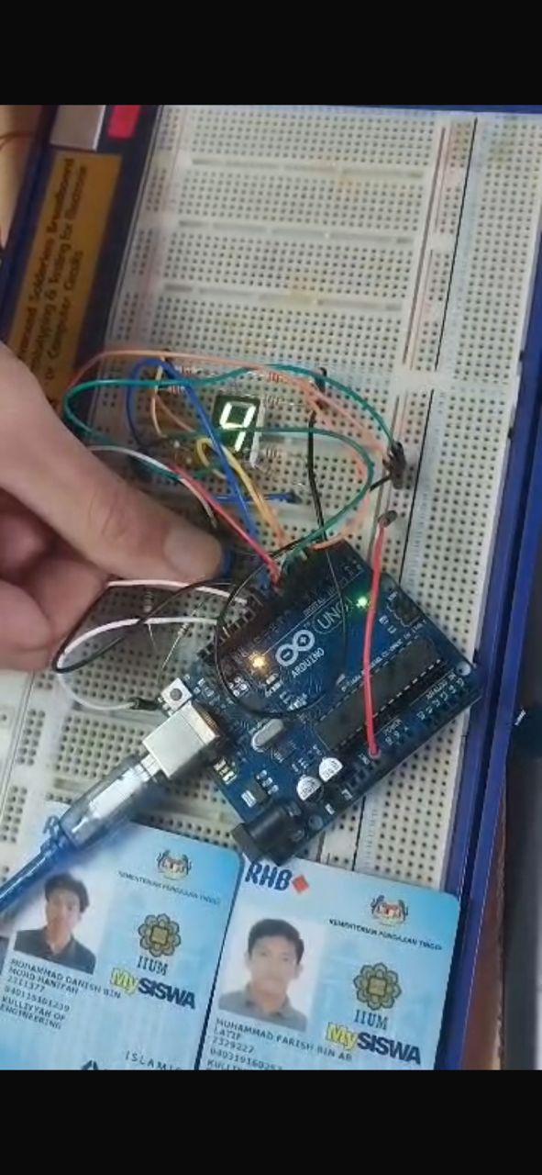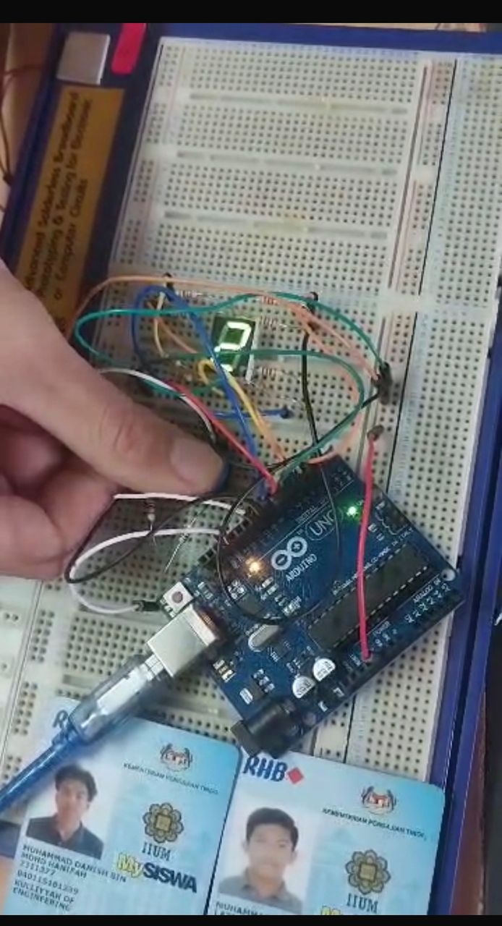

ACKNOWLEDGEMENT

We would like to sincerely express our gratitudes to our instructors, Assoc. Prof. Eur. Ing. Ir.
Ts. Gs. Inv. Dr. Zulkifli Bin Zainal and the lab technician, for the help given during the task. The knowledge and suggestions are able to guide us throughout the progress of the task. We also would like to thank our classmates for their support and help which really give positive impacts to the progression of our task.

STUDENTS’ DECLARATION
We certify that this report is entirely our own work, except where we have given fully documented references to the work of others, and that the material in this assignment has not previously been submitted for assessment in any formal course of study.
We understand that plagiarism, falsification, and fabrication of data are serious academic offences and may result in disciplinary action under the regulations of International Islamic University Malaysia. Therefore, we take full responsibility for the originality and authenticity of this report.
Signature:
Name: MUHAMMAD DANISH BIN MOHD HANIFAH
Matric Number: 2311377

Signature:
Name: MUHAMMAD FARISH BIN AB LATIF
Matric Number: 2329227

Signature:
Name: MUHAMMAD FARQI SARHIDI BIN ABDUL HAFAZ
Matric Number: 2316461

